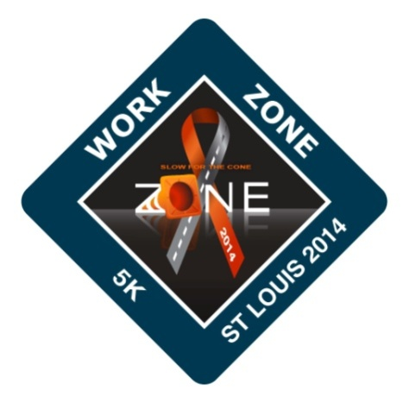

5K & 1 Mile Fun Run/Walk

April 12, 2014 – MoDOT Traffic Management Center

Registration – 7 am; Race/Walk – 8 am

Volunteer Commitment Form

Volunteer Contact Information
Name:
Company:
Phone: |  | Email:

T-Shirt Size:

Website: http://workzone5k.itsyourrace.com/event.aspx?id=283
For more information please contact Tom Blair: 314.453.1803 or Thomas.Blair@modot.mo.gov.
WORK ZONE AWARENESS

St. Louis Metro District Office
Traffic Management Center
1590 Woodlake Drive
Chesterfield, Mo 63017
314-275-1500

THANK YOU FOR YOUR SUPPORT!

