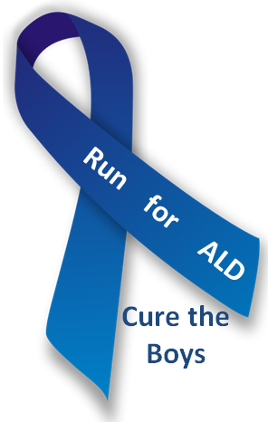
5K & 1 Mile
November 17th, 2018
Proceeds to benefit ALD Research

Location and Time: Creve Coeur Park, Tremayne Shelter
13725 Marine Ave, Maryland Heights, MO 63043
5K Run / 1 Mile Walk: 9:00 AM
Entry Details: Register by November 01, 2018: - $25
Register after November 01, 2018: - $35
Register via paper form below or online at:
http://www.fleetfeetstlouis.com/racing/run-for-ALD
All checks should be made payable to Knockout ALD, Inc.
T-Shirts: All participants receive a short sleeve tech T-shirt
Awards: 5K: Male and Female: 10 and Under; 11-14; 15-19; 20-29; 30-39; 40-49; 50-59; 60-69; 70+
Packet Pick Up: Friday November 16th from 3:30 PM to 6:30 PM Knockout ALD Office
841 Gardenway Dr., Ballwin, MO 63011
Race morning at Creve Coeur Park, Tremayne Shelter from 7:00 AM to 8:15 AM
Event Contact: For additional information, contact Julie/Dave Purschke at RunforALD@yahoo.com ______________________________________________________________________________________________
Checks should be made payable to Knockout ALD, Inc.
Please mail to Knockout ALD, 841 Gardenway Dr., Ballwin, MO 63011.

First Name: _____________________________ Last Name: ____________________________________________

Address: _________________________________City: _______________________ State: ________ Zip:_________

DOB: _________________ Age on Race Day: ______

Phone: __________________________ E-Mail: _______________________________________________________
Gender:  Male  Female Race:  5K Run / Walk  1 Mile Run / Walk
Shirt Size:  Youth S  Youth M  Youth L  Youth XL  Adult S  Adult M  Adult L  Adult XL

Waiver: In consideration of your accepting this entry, I, intending to be legally bound, hereby for myself, my heirs, my executors, and administrators, waive, and release any and all rights and claims or damages I may have against David and Julie Purschke, Knockout ALD, Inc, University of Minnesota Foundation, Fleet Feet Sports, Red Iguana Racing, and St. Louis County Parks and Recreation, their affiliates, subsidiaries, officials, representatives, employees, successors, volunteers, and assigns for any and all injuries suffered by me in these events. I attest and verify that I am physically fit and have sufficiently trained for the completion of these events. Further, I hereby grant full permission for the free use of my name and/or photographs, videotapes, motion pictures, recordings, or any other record of this event for any legitimate purpose. My submission of this form shall act as my legal signature.

Signature: _______________________________________________________ Date: _________________________
(Parent or Guardian must sign if under 18 years old)

